**Aura watches**

|  |  |
| --- | --- |
| **Supervisor** | Muhammad Hamza |
| **Batch** | 2309E2 |
| **Group** | E |
| **Student name** | Azan Ali, Muhammad Abdullah, Muneeb ur Rehman |
| **Enrollment no.** | Student.1509527, Student.1509514, Student.1508381 |

**Navbar**:

* Home
* Products
* Technology
* Store locator
* Contact us

**HOME**

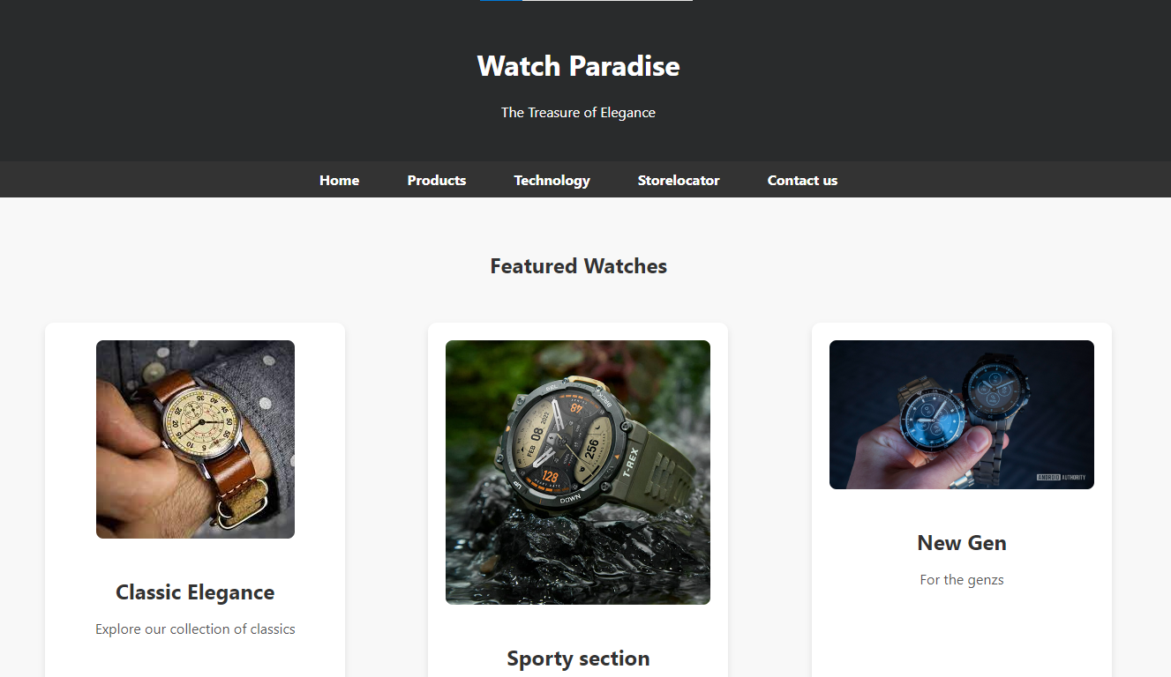

* This is the home page of our watch website. In this tab we are showing the types and variety of watches available for the customers. Its design is professional and decent. This has gone through some fine coding.

**Products**

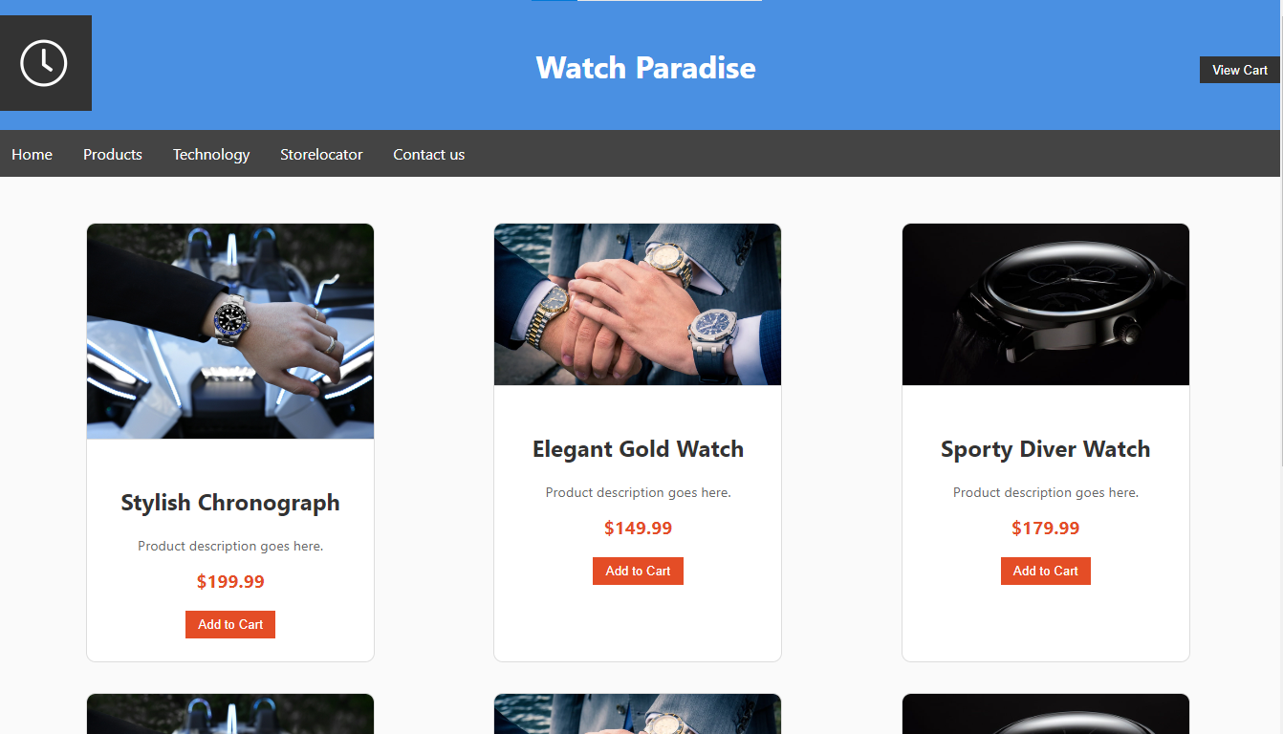

* This is the proucts tab of our website.In this tab we are showcasing our watches to our customers along with their prizes.The products which are picked by the customers can be added to cart.This tab has been made from excellent js along with Html and Css.

**Technology**

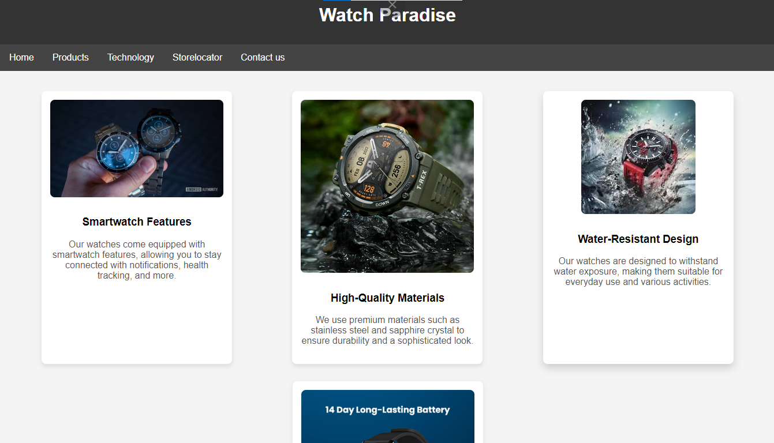

* In this tab we are describing the qualities of our watches. Each quality is described by well suited words. Technology for our watches will catch the site of our customers so it has been done perfectly.

**Store locator**

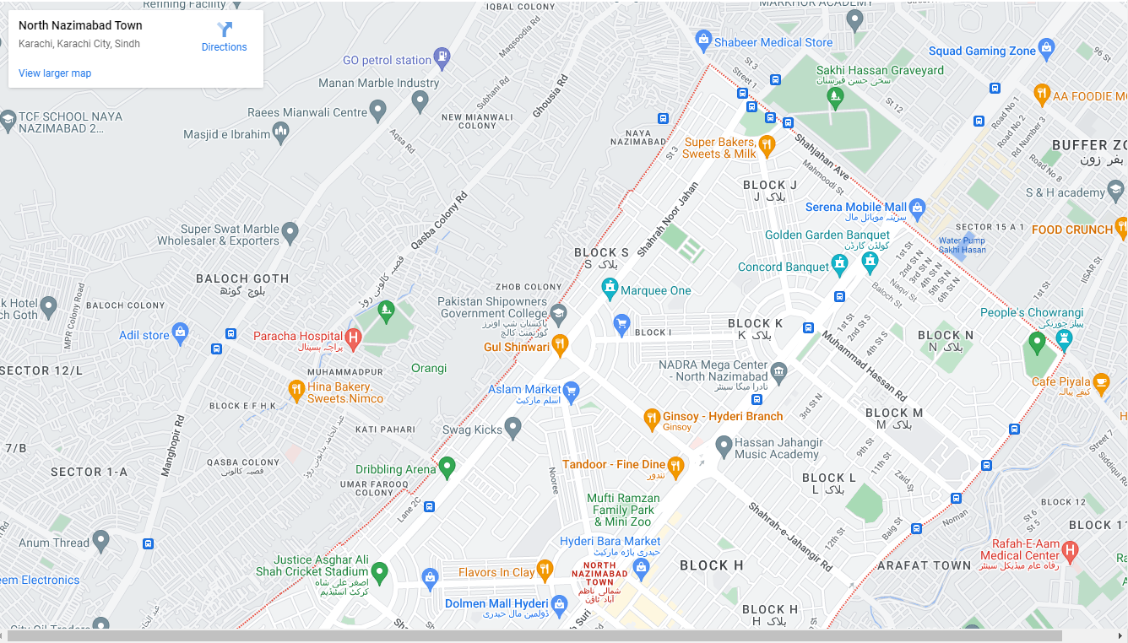

**Contact us**

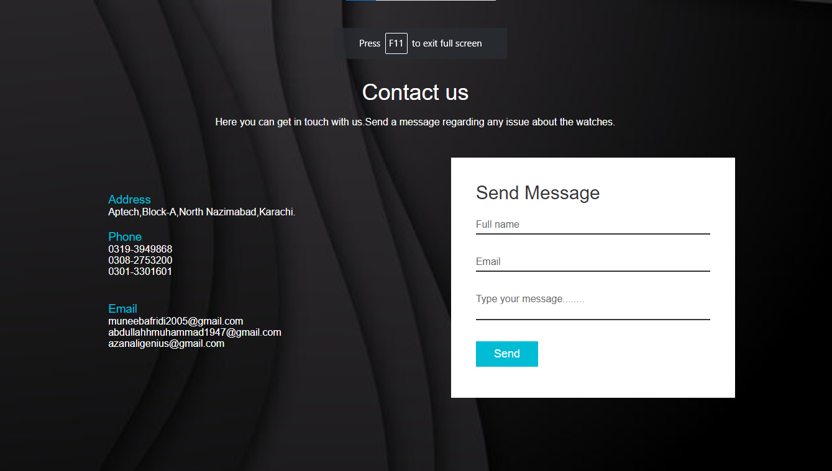

* This tab is focused on contact of the customer with the owner. Our customers will be able to give their reviews about the website as well state any problem.